Inner Guidance By the Gulf:
Accessing Your Deep Inner Wisdom Through Creative Process

A weekend retreat facilitated by Beverly Gordon
February 28-March 1, 2020

WHAT
This workshop is designed for those who want to access and deepen their relationship with their own inner wisdom, or spirit of guidance. We use a variety of tools and experiences that draw on expressive arts and creative process: SoulCollage®; Soul Scribbles; “New Viewfinding”—creative explorations using photography (easy exercises with a phone or digital camera); and Soul-Guided Writing. In addition, we have time for a ritual circle on a peaceful Gulf of Mexico beach and other interactions with nature. We create a safe, supportive community and our work is done within a sacred energetic container.

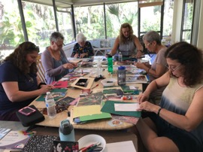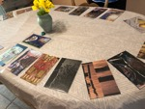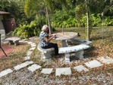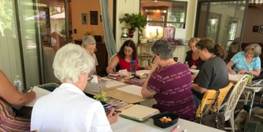

WHERE
The location is Casa Nur, a beautiful private home and studio in the Venice/ Englewood, Florida area on the Gulf of Mexico. (For info on the area, visit https://www.visitsarasota.com/ and https://www.visitflorida.com/en-us/cities/venice.html). The house is a 1-minute drive/10-minute walk to a quiet public beach on Manasota Key. Casa Nur offers ample work space (in good weather—which is most of the time—we use the lanai, enjoying the varied greens of the landscape, just beyond the screen), and grounds and gardens to wander or work in.

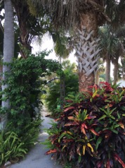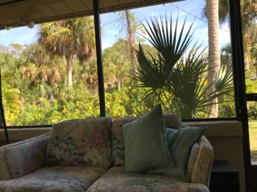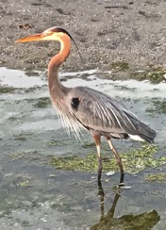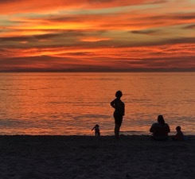
The weather in late February is usually quite pleasant: averaging about 75 degrees during the day and about 60 degrees at night, with minimal rain.
Here’s a video about Manasota beach: https://www.youtube.com/watch?v=mpyD5SplLi0

LOGISTICS
Workshop fee: $290. All workshop materials are provided. Housing and most meals are not included, except for a feast on Saturday evening.

Accommodations: There are many nearby accommodations, and the facilitator can help with arrangements. (Two places within walking distance to check out: The Seafarer Beach motel, (941) 474-4388, http://www.seafarerbeach.com/; and the Manasota Bridge motel, (941) 474-5365).

Air travel: The closest airports are in Sarasota, Fort Meyers, or Punta Gorda, Florida. Tampa or St. Pete/Clearwater are a little further afield, but within a 1.5 hour drive. There is no public transportation to Casa Nur, but the facilitator can help set you up with a driver service. Those coming from out of the area should plan to arrive Thursday evening.

THE FACILITATOR
Beverly Gordon is an artist, writer, and workshop leader, committed to helping others access their own inner wisdom and rediscover their creative energy and sense of wonder. An experienced SoulCollage® facilitator, she also leads workshops such as “Cultivating Wonder,” Stepping into the Wisdom of Trees, and “Writing From the Inside Out.” She is a retired university professor (Design Studies, Univ. of Wisconsin-Madison) and a skilled group leader, teacher, and public speaker. To get a sense of her art work and the range of her workshop offerings, , visit her website: www.beverlygordon.info. Check out the blog, which includes many images of Casa Nur and the Manasota Beach environs.

FOR MORE INFO OR TO REGISTER: Contact facilitator Beverly Gordon
bgordon@wisc.edu; (608) 658-7144; www.beverlygordon.info

TESTIMONIALS FROM THE 2019 WORKSHOP
It was like being in a safe and cozy space in which we were free to be alone and with others, exploring soul deep territory.
The workshop as a whole was very precious to me. I loved the exercises we did. I was inspired by these opportunities to try something different.
I wanted to do meaningful deep work [and connect with others who did as well.] I felt that there was deep listening among our group. This kind of connection seems to be essential to my being.
I would recommend you as a facilitator anytime based on this retreat. You held the space in an encompassing way that created safety almost immediately. And your depth of experience with what you were sharing…you ‘maturity’….were important for me to feel safe.
Your home was a lovely place to work….plenty of space and various areas for us to work in… I liked the variety and the spaciousness. I especially appreciated your back garden-- jungle-like and oh-so-green.
DETAILS
More on some of the processes we will explore:
**SoulCollage® is a simple, magical and powerful process of combining visual images (cutting and pasting from printed photos--no particular skill or experience needed) to access information from your deeper self, and then letting the collages “speak.” Participants create collaged cards with their own visual symbolic language. Together, the cards form a unique "deck” that can be as a personal discovery tool—a personal oracle. For more info, visit www.soulcollage.com

**Soul Scribbles are quick exercises using quick scribbles or doodles to get at some of the ideas and issues operating beyond the conscious level.

**Soul-Guided Writing is an empowering form of journaling that allows the inner voice of guidance to come through as a kind of personal channel. Akin to what is sometimes called automatic writing, the process is multi-sensory, and involves directing questions to that wise teacher. Guidance often shows up in surprising and delightful ways.

**New Viewfinding is literally playing with new perspectives through a camera lens (easy to do with a simple phone or digital camera; no photography skill is necessary). Enjoyable “looking and capturing” exercises expand creative understanding and lead to different ways of thinking and seeing.

** Surprises—Unexpected opportunities for giving and receiving.

SAMPLE SCHEDULE (subject to serendipity and change!)
Friday, February 28, 2020
10:00-11:30 Gather and meet one another. Orientation to the area and set-up of the workshop. Learn about our group and individual intentions. Explore the idea of inner guidance and the higher self.

11:30-12:30 Weather permitting, opening ritual on beach and picnic lunch (bring your own or we’ll have a selection of items to build sandwiches).

1:00-5:00 SoulCollage®, session 1. Collage-making and interpretation.

Dinner on your own (individuals may choose to go out to a restaurant together).

Saturday, February 9, 2020 (leap day!)
9:30-10:00 Gathering and greeting the day.

10:00-11:00 Soul Scribble and other playful exercises.

11:00-12:00 Soul-guided writing

12:00-12:30 Introduction to New Viewfinding

12:30-3:00 Lunch break and personal reflection time. Opportunity for walks, journaling, and New Viewfinding camera exercises. Stay on the grounds or go to the beach or nearby natural areas.

3:00-6:00 Share mid-day explorations. SoulCollage®, session 2 .

6:00 Sunset beach viewing for those who wish.

7:00 Dinner at Casa Nur.

Sunday, March 1, 2020
9:30-10:00 Gathering and greeting the day.

10:00-12:00 SoulCollage®, soul-guided writing or other guided experiences.

12:00 Snack

12:15-1:30 Final activities, sharing and closing ritual.

FOR MORE INFO OR TO REGISTER: Contact facilitator Beverly Gordon
bgordon@wisc.edu; (608) 658-7144; www.beverlygordon.info

